**P2.3 Question**

To do...

1) Read the question carefuly

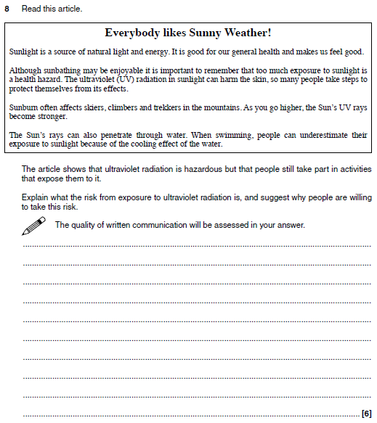

2) What topic is this question about _______________

3) Brainstorm as many of the keywords or phrases that you think should be included in the answer.

4) Now have a think about the order or sequence you would put these keywords or phrases in.

5) Now have a go at answering the question before looking at the mark scheme

**P2.3 Answer**

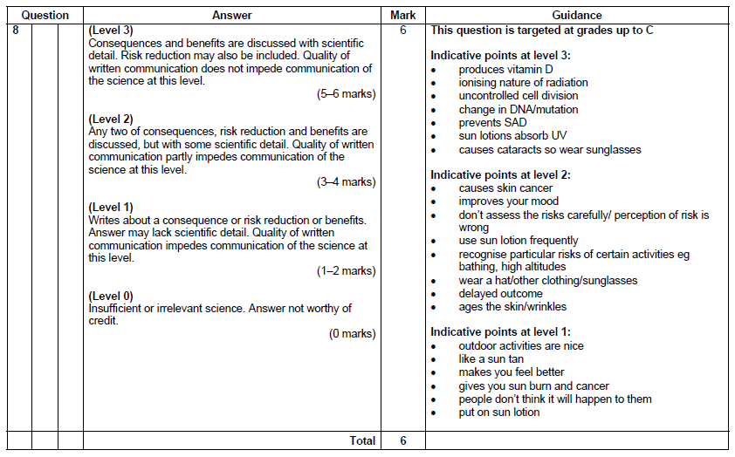

6) Use the mark scheme to see how well you did. Below, see if you can come up with the perfect response

_____________________________________________________________________________________________________________________________________________________________________________________________________________________________________________________________________________________________________________________________________________________________________________________________________________________________________________________________________________________________________________________________________________________________________________________________________________________________________________________________________________________________________________________________________________________________________________________________________________________________________________________________________________________________________________________________________________________________________________________________________________________________________________________________________________________________________________________________________________________________________________________________________________________________________________________________________________________________________________________________________________________________________________________________________________