[](http://www.oup.com/oxed/secondary/science/c21science)

**GCSE Additional Science**

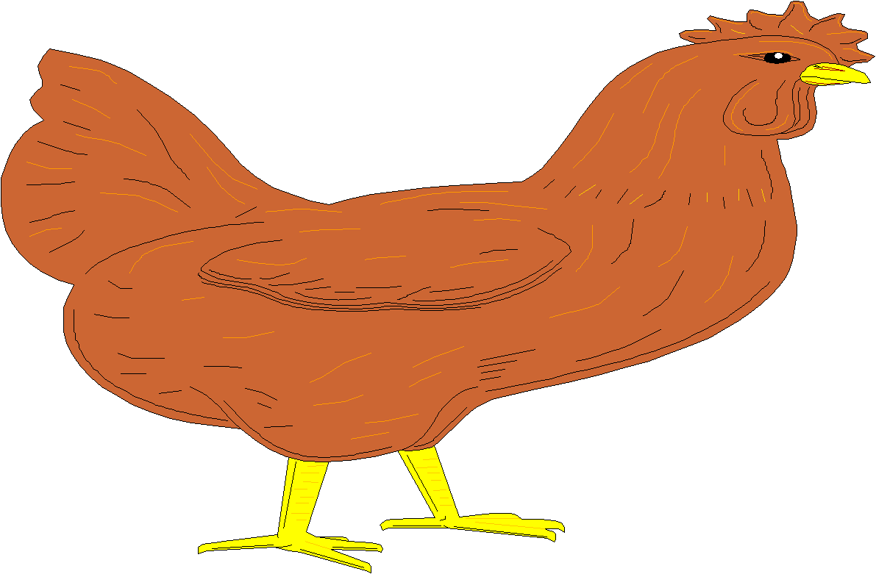



**Module B5 – Growth and Development;**

**What you should know**

|  |
| --- |
| **Name:**  **Science Group:**  **Teacher:** |

**R.A.G. each of the statements to help focus your revision:**

*R = Red: I don’t know this*

*A = Amber: I partly know this*

*G = Green: I know this*

|  |  |
| --- | --- |
| **B5.1 How do organisms develop?** | **R.A.G.** |
| I can recall that cells in multicellular organisms can be specialised to do particular jobs |  |
| I can recall that groups of specialised cells are called tissues, and groups of tissues form organs |  |
| I can recall that a fertilised egg cell (zygote) divides by mitosis to form an embryo |  |
| I can recall that in a human embryo up to (and including) the eight cell stage, all the cells are identical (embryonic stem cells) and could produce any type of cell required by the organism |  |
| I understand that after the eight cell stage, most of the embryo cells become specialised and form different types of tissue |  |
| I understand that some cells (adult stem cells) remain unspecialised and can become specialised, at a later stage, to become many, but not all, types of cell required by the organism |  |
| I understand that in plants, only cells within special regions called meristems are mitotically active 8. understand that the new cells produced from plant meristems are unspecialised and can develop into any kind of plant cell |  |
| I understand that unspecialised plant cells can become specialised to form different types of issue (including xylem and phloem) within organs (including flowers, leaves, stems and roots) |  |
| I understand that the presence of meristems (as sources of unspecialised cells) allows the production of clones of a plant from cuttings, and that this may be done to reproduce a plant with desirable features |  |
| I understand that a cut stem from a plant can develop roots and then grow into a complete plant which is a clone of the parent, and that rooting can be promoted by the presence of plant hormones (**auxins**) |  |
| I understand that the growth and development of plants is also affected by the environment, e.g. phototropism |  |
| I understand how phototropism increases the plant’s chance of survival |  |
| **I can explain phototropism in terms of the effect of light on the distribution of auxin in a shoot tip.** |  |

|  |  |
| --- | --- |
| **B5.2 How does an organism produce new cells?** | **R.A.G.** |
| I can recall that cell division by mitosis produces two new cells that are genetically identical to each other and to the parent cell |  |
| I can describe the main processes of the cell cycle:  a. cell growth during which:  • numbers of organelles increase  • the chromosomes are copied when the two strands of each DNA molecule  separate and new strands form alongside them  b. mitosis during which:  • copies of the chromosomes separate  • the nucleus divides |  |
| I can recall that meiosis is a type of cell division that produces gametes |  |
| I understand why, in meiosis, it is important that the cells produced only contain half the chromosome number of the parent cell |  |
| I understand that a zygote contains a set of chromosomes from each parent. |  |

|  |  |
| --- | --- |
| **B5.3 How do genes control growth and development within the cell?** | **R.A.G.** |
| I can recall that DNA has a double helix structure |  |
| I can recall that both strands of the DNA molecule are made up of four different bases which always pair up in the same way: A with T, and C with G |  |
| I understand that the order of bases in a gene is the genetic code for the production of a protein |  |
| **I can explain how the order of bases in a gene is the code for building up amino acids in the correct order to make a particular protein** |  |
| I can recall that the genetic code is in the cell nucleus of animal and plant cells but proteins are produced in the cell cytoplasm |  |
| I understand that genes do not leave the nucleus but a copy of the gene (**messenger RNA**) is produced to carry the genetic code to the cytoplasm |  |
| I understand that although all body cells in an organism contain the same genes, many genes in a particular cell are not active (switched off) because the cell only produces the specific proteins it needs |  |
| I understand that in specialised cells only the genes needed for the cell can be switched on, but in embryonic stem cells any gene can be switched on during development to produce any type of specialised cell |  |
| I understand that adult stem cells and embryonic stem cells have the potential to produce cells needed to replace damaged tissues |  |
| I understand that ethical decisions need to be taken when using embryonic stem cells and that this work is subject to Government regulation |  |
| **I understand that, in carefully controlled conditions of mammalian cloning, it is possible to reactivate (switch on) inactive genes in the nucleus of a body cell to form cells of all tissue types.** |  |

|  |  |
| --- | --- |
| **Grades A* - C (Higher)** | All statements shown in **bold** as well as all statements shown in normal type. |
| **Grades C – G (Foundation)** | All statements shown in normal type. |