[](http://www.oup.com/oxed/secondary/science/c21science)

**GCSE Science**

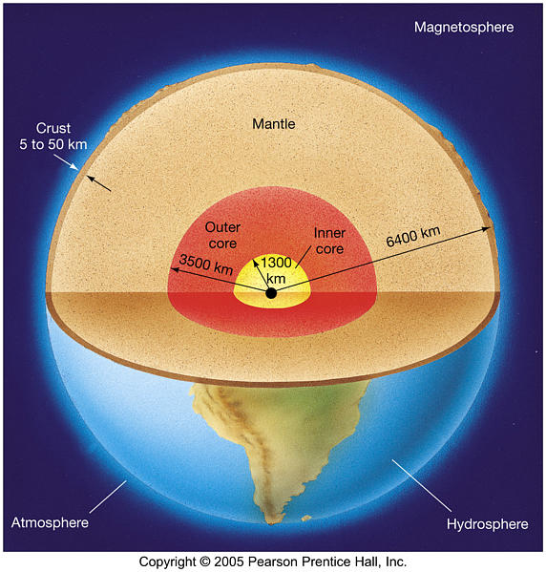

**Module P1 – The Earth in the Universe**

**What you should know**

|  |
| --- |
| **Name:**  **Science Group:**  **Teacher:** |

**R.A.G. each of the statements to help focus your revision:**

*R = Red: I don’t know this A = Amber: I partly know this G = Green: I know this*

|  |  |  |
| --- | --- | --- |
| **P1.1 What do we know about the place of the Earth in the Universe?** | | **R.A.G.** |
| I can recall that the Earth is one of eight planets moving in almost circular paths round the Sun which, together with other smaller objects orbiting the Sun (asteroids, dwarf planets, comets) and moons orbiting several planets, make up the solar system | |  |
| I can describe the principal differences between planets, moons, the Sun, comets and asteroids including their relative sizes and motions | |  |
| I understand that the solar system was formed over very long periods from clouds of gases and dust in space, about five thousand million years ago | |  |
| I can recall that the Sun is one of thousands of millions of stars in the Milky Way galaxy | |  |
| I can recall that there are thousands of millions of galaxies, each containing thousands of millions of stars, and that all of these galaxies make up the Universe | |  |
| I can put in order and recall the relative sizes of: the diameters of the Earth, the Sun, the Earth’s orbit, the solar system, the Milky Way, the distance from the Sun to the nearest star, and the distance from the Milky Way to the nearest galaxy | |  |
| I understand that all the evidence we have about distant stars and galaxies comes from the radiation astronomers can detect | |  |
| I can recall that light travels through space (a vacuum) at a very high but finite speed, 300 000 km/s | |  |
| I can recall that a light-year is the distance travelled by light in a year | |  |
| I understand that the finite speed of light means that very distant objects are observed as they were in the past, when the light we now see left them | |  |
| I understand how the distance to a star can be measured using parallax (qualitative idea only) | |  |
| I understand how the distance to a star can be estimated from its relative brightness | |  |
| I understand that light pollution and other atmospheric conditions interfere with observations of the night sky | |  |
| I can explain why there are uncertainties about the distances of stars and galaxies with reference to the nature and difficulty of the observations on which these are based and the assumptions made in interpreting them | |  |
| I understand that the source of the Sun’s energy is the fusion of hydrogen nuclei | |  |
| I understand that all chemical elements with atoms heavier than helium were made in stars | |  |
| **P1.1 What do we know about the place of the Earth in the Universe? *Continued*** | **R.A.G.** | |
| I understand that **the redshift in the light coming from them suggests that** distant galaxies are moving away from us |  | |
| **I understand that (in general) the further away a galaxy is, the faster it is moving away from us** |  | |
| **I understand how the motions of galaxies suggests that space itself is expanding** |  | |
| I can recall and put in order the relative ages of the Earth, the Sun, and the Universe |  | |
| I can recall that scientists believe the Universe began with a ‘big bang’ about 14 thousand million years ago |  | |
| I understand that the ultimate fate of the Universe is difficult to predict because of difficulties in measuring the very large distances involved **and the mass of the Universe**, and studying the motion of very distant objects. |  | |

|  |  |
| --- | --- |
| **P1.2 What do we know about the Earth and how it is changing?** | **R.A.G.** |
| I understand how rocks provide evidence for changes in the Earth (erosion and sedimentation, fossils, folding) |  |
| I understand that continents would be worn down to sea level by erosion, if mountains were not being continuously formed |  |
| I understand that the rock processes seen today can account for past changes |  |
| I understand that the age of the Earth can be estimated from, and must be greater than, the age of its oldest rocks, which are about four thousand million years old |  |
| I understand Wegener’s theory of continental drift and his evidence for it (geometric fit of continents and their matching fossils and rock layers) |  |
| I understand how Wegener’s theory accounts for mountain building |  |
| I understand reasons for the rejection of Wegener’s theory by geologists of his time (movement of continents not detectable, too big an idea from limited evidence, simpler explanations of the same evidence, Wegener an outsider to the community of geologists) |  |
| I understand that seafloor spreading is a consequence of movement of the mantle (convection due to heating by the core) |  |
| I recall that seafloors spread by a few centimetres a year |  |
| **I understand how seafloor spreading and the periodic reversals of the Earth’s magnetic field can explain the pattern in the magnetisation of seafloor rocks on either side of the oceanic ridges** |  |
| I understand that earthquakes, volcanoes and mountain building generally occur at the edges of tectonic plates |  |
| **P1.2 What do we know about the Earth and how it is changing? *Continued*** | **R.A.G.** |
| **I understand how the movement of tectonic plates causes earthquakes, volcanoes and mountain building, and contributes to the rock cycle** |  |
| I can recall that earthquakes produce wave motions on the surface and inside the Earth which can be detected by instruments located on the Earth’s surface |  |
| I can recall that earthquakes produce:  a) P-waves (**longitudinal waves**) which travel through solids and liquids  b) S-waves (**transverse waves**) which travel through solids but not liquids |  |
| I can describe the difference between a transverse and longitudinal wave |  |
| I understand how differences in the **wave speeds** and behaviour of P- and S-waves can be used to give evidence for the structure of the Earth |  |
| In relation to waves, I can use the equation:  Distance (m) = wave speed ( m/s) × time ( s) |  |
| I can draw and label a diagram of the Earth to show its crust, mantle and core |  |
| I can recall that a wave is a disturbance, caused by a vibrating source, that transfers energy in the direction that the wave travels, without transferring matter |  |
| I can recall that the frequency of waves, in hertz (Hz), is the number of waves each second that are made by the source, or that pass through any particular point |  |
| I can recall that the wavelength of waves is the distance between the corresponding points on two adjacent cycles |  |
| I can recall that the amplitude of a wave is the distance from the maximum displacement to the undisturbed position |  |
| I can draw and interpret diagrams showing the amplitude and the wavelength of waves |  |
| I can use the equation:  wave speed (m/s) = frequency (hertz, Hz) × wavelength (m) |  |
| I understand that for a constant wave speed the wavelength of the wave is inversely proportional to the frequency. |  |

|  |  |
| --- | --- |
| **Grades A* - C (Higher)** | All statements shown in **bold** as well as all statements shown in normal type. |
| **Grades C – G (Foundation)** | All statements shown in normal type. |